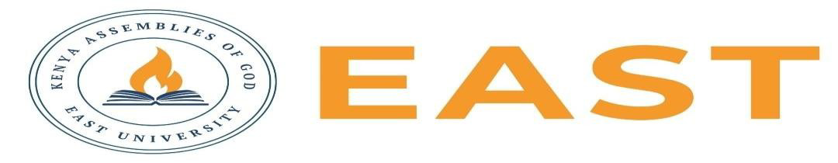

FINAL EXAMINATIONS
SCHOOL OF EDUCATION AND SOCIAL SCIENCES
KITENGELA CAMPUS
2025/2026 ACADEMIC YEAR
EXAMINATION FOR COMMUNITY DEVELOPMENT TVET
APPLYING HUMAN RIGHTS AND SOCIAL JUSTICE
STREAM: TVET: 03110506B TIME: 2 HOURS
EXAMINATION SESSION: AUGUST 2026 YEAR: 2026
DAY [31 ] DATE: [ 2026]
INSTRUCTIONS:
- Attempt ALL the questions in Section A
- Attempt any Two questions in Section B
- The entire exam is worth sixty (40) marks.
- Write ONLY on the space provided on the answer sheet or as otherwise instructed.
- Where necessary Show your working clearly.
- Do NOT attempt to access any library, online (audio, video, digital or electronic) or paper based (written), sources for your answers unless this is clearly advised in the Question.

SECTION A: COMPULSORY (20 marks)
Question 1
- Discuss four reasons why human rights laws are important in society. (4 marks)
- State four characteristics of a social movement. (4 marks)
- List four roles of trade unions in protecting workers' rights. (4 marks)
- State four ways in which global advocacy promotes social justice and human rights. (4 marks)
- Differentiate between civil rights and political rights. (4 marks)

SECTION B: ANSWER ANY TWO (20 Marks)
Question 1
Analyze the theory of intersectionality and discuss its importance in understanding the experiences of marginalized and vulnerable groups.( 10 marks)

Question 2
Critically assess the role of international organizations and human rights mechanisms in protecting and promoting human rights globally.( 10 mark)

Question 3
Discuss the concept of digital rights and explain five rights that every internet user should enjoy. (10 marks)

