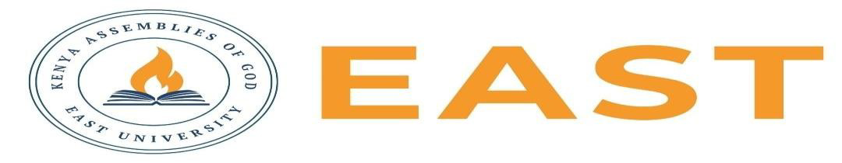

FINAL EXAMINATIONS
SCHOOL OF EDUCATION AND SOCIAL SCIENCES
KITENGELA CAMPUS
2025/2026 ACADEMIC YEAR
EXAMINATION FOR THE DEGREE IN BUSINESS ADMINISTRATION
BUSINESS LAW 11
STREAM: BBA 2263 TIME: 2 HOURS
EXAMINATION SESSION: AUGUST 2026 YEAR: 2026
DAY [31 ] DATE: [ 2026]
INSTRUCTIONS:
- Attempt ALL the questions in Section A
- Attempt any Two questions in Section B
- The entire exam is worth sixty (40) marks.
- Write ONLY on the space provided on the answer sheet or as otherwise instructed.
- Do NOT attempt to access any library, online (audio, video, digital or electronic) or paper based (written), sources for your answers unless this is clearly advised in the Question.

SECTION A (20 MARKS)
Question 1
- Distinguish between a public company and a private company. (4 marks)
- List four rights of a debenture holder(4 marks)
- Differentiate between ordinary shares and preference shares.(4 marks)
- State four duties of a company directors (4 marks)
- List four functions of a prospectus. (4 marks)

SECTION B: ANSWER ANY TWO (20 MARKS)
Question 1
Explain the doctrine of lifting the corporate veil. Discuss the circumstances under which courts will disregard the separate legal personality of a company.( 10 marks)

Question 2
A business owner wishes to expand operations by converting a sole proprietorship into a company. Discuss the advantages and disadvantages of incorporation and advise the owner on whether incorporation would be beneficial.( 10 marks)

Question 3
Discuss the benefits and challenges of mergers, acquisitions, and take-overs as strategies for corporate restructuring and business growth.(10 marks)

