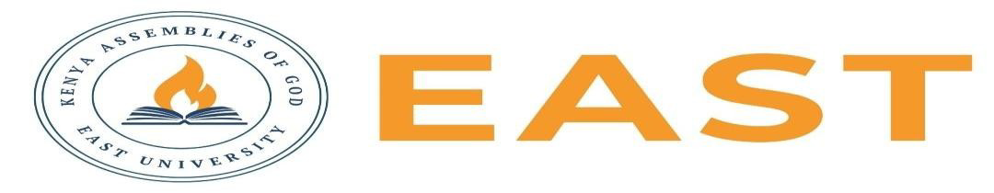

FINAL EXAMINATIONS
SCHOOL OF EDUCATION AND SOCIAL SCIENCES
KITENGELA CAMPUS
SECOND SEMESTER, 2025/2026 ACADEMIC YEAR
EXAMINATION FOR COUNSELING PHYCHOLOGY
CODE; BCOP 4153
ETHICAL AND LEGAL ISSUES IN COUNSELLING
EXAMINATION SESSION: AUGUST 2026 YEAR: 2026
DAY [31 ] TIME - 2 HOURS

INSTRUCTIONS:
- Attempt ALL the questions in Section A
- Attempt any Two questions in Section B
- The entire exam is worth sixty (40) marks.
- Write ONLY on the space provided on the answer sheet or as otherwise instructed.
- Do NOT attempt to access any library, online (audio, video, digital or electronic) or paper based (written), sources for your answers unless this is clearly advised in the Question.

SECTION A (20 MARKS)
Question 1
- State the four core ethical principles in counseling.(4 marks)
- List four major counseling codes of ethics.(4 marks)
- Mention two risks associated with boundary violations.(2 marks)
- Discuss four exceptions to confidentiality in counselling (4 marks)
- What is digital informed consent?( 2 marks)
- List four reasons why data security is important in online counseling. (4 marks)

SECTION B: ANSWER ANY TWO (20 MARKS)

Question 1
Examine the ethical and legal obligations of counselors regarding confidentiality and informed consent. Discuss the circumstances under which confidentiality may be legally breached.(10 marks)
Question 2
Analyze the challenges posed by dual relationships in counseling practice and evaluate strategies that counselors can use to maintain professional boundaries.(10 marks)
Question 3
Critically discuss the role of ethical decision-making models in resolving counseling dilemmas. Illustrate your answer with practical examples.(10 marks)

