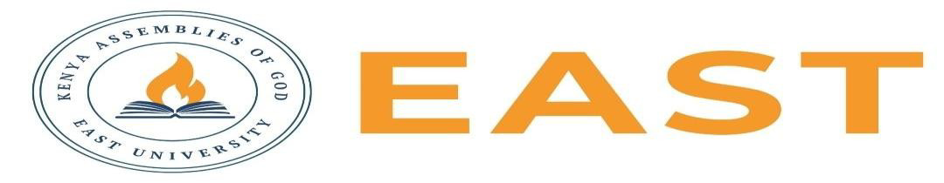

FINAL EXAMINATIONS
SCHOOL OF EDUCATION AND SOCIAL SCIENCES
KITENGELA CAMPUS
FIRST SEMESTER, 2025/2026 ACADEMIC YEAR
EXAMINATION FOR DIPLOMA IN BUSINESS ADMINISTRATION
BUSINESS LAW 1
STREAM: TVET :DBA 213
TIME: 2 HOURS
EXAMINATION SESSION: AUGUST 2026 YEAR: 2026
DAY [31 ] DATE: [ 2026]
INSTRUCTIONS:
- Attempt ALL the questions in Section A
- Attempt any Two questions in Section B
- The entire exam is worth sixty (40) marks.
- Write ONLY on the space provided on the answer sheet or as otherwise instructed.
- Where necessary Show your working clearly.
- Do NOT attempt to access any library, online (audio, video, digital or electronic) or paper based (written), sources for your answers unless this is clearly advised in the Question.

SECTION A ( 20 MARKS)
Question 1
- State five conditions under which ownership in goods passes from seller to buyer. (5 marks)
- List five legal remedies available for breach of contract by either party. (5 marks)
- State five characteristics of an agency. (5 marks)
- List five characteristics of a negotiable instrument. (5 marks)

SECTION B: ANSWER ANY TWO QUESTIONS (20 MARKS)
Question 1
Discuss the essential elements of a valid contract and explain the legal consequences where any of these elements is absent.(10 marks)

Question 2
Discuss the rights and duties of an unpaid seller and explain the remedies available in cases of breach of a contract of sale.(10 marks)

Question 3
Define the terms reconstitution and dissolution of a partnership, and List the causes of reconstitution and dissolution, and explain what happens to the firm's assets and liabilities during dissolution. ( 10 marks)

