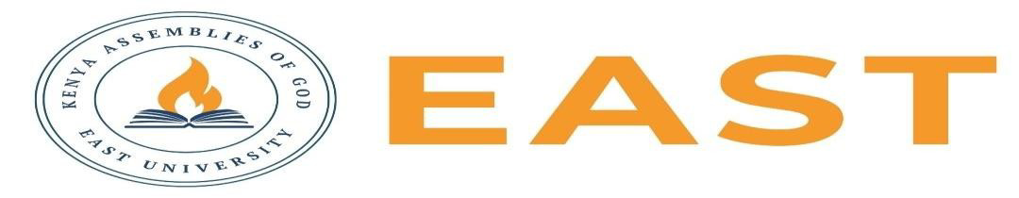

FINAL EXAMINATIONS
SCHOOL OF EDUCATION AND SOCIAL SCIENCES
KITENGELA CAMPUS
SECOND SEMESTER, 2025/2026 ACADEMIC YEAR
EXAMINATION FOR COUNSELING PSYCHOLOGY TVET
APPLYING ETHICAL AND LEGAL ISSUES IN COUNSELLING PSYCHOLOGY
STREAM: 03131205B TIME: 2 HOURS
EXAMINATION SESSION: AUGUST 2026 YEAR: 2026
DAY [31 ] DATE: [ 2026]
INSTRUCTIONS:
- Attempt ALL the questions in Section A
- Attempt any Two questions in Section B
- The entire exam is worth sixty (40) marks.
- Write ONLY on the space provided on the answer sheet or as otherwise instructed.
- Where necessary Show your working clearly.
- Do NOT attempt to access any library, online (audio, video, digital or electronic) or paper based (written), sources for your answers unless this is clearly advised in the Question.

SECTION A COMPULSORY (20 MARKS)
Question 1
- State the four core ethical principles in counselling. (4 marks)
- State four exceptions to confidentiality in counselling. (4 marks)
- State four purposes of maintaining counselling records. (4 marks)
- Explain two responsibilities of a supervisee in counselling supervision. (4 marks)
- List four challenges counsellors face when balancing universal ethical principles with cultural values. (4 marks)

SECTION B: ANSWER ANY TWO (20 MARKS)
Question 1
During a counselling session, a client reveals plans to seriously harm another person and asks the counsellor to keep the information confidential. Discuss the ethical principles involved and explain how the counsellor should respond.( 10 marks)

Question 2
Compare the strengths and limitations of utilitarianism and deontology in resolving ethical issues.( 10 marks)

Question 3
Analyze five challenges of maintaining professional boundaries in counselling practice and explain strategies that counsellors can use to avoid ethical violations.( 10 marks)

