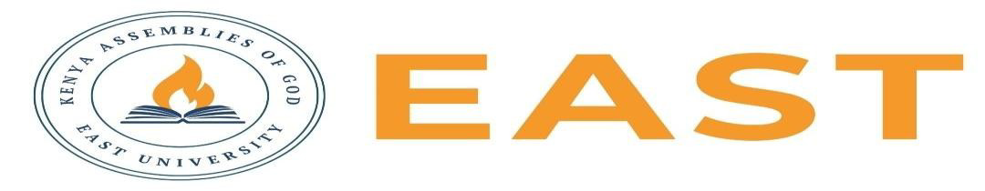

FINAL EXAMINATIONS
SCHOOL OF EDUCATION AND SOCIAL SCIENCES
KITENGELA CAMPUS
2025/2026 ACADEMIC YEAR
EXAMINATION FOR THE DIPLOMA IN BUSINESS ADMINISTRATION
STREAM: TVET :04130305B APPLYING BUSINESS ETHICS
TIME: 2 HOURS
EXAMINATION SESSION: AUGUST 2026 YEAR: 2026
DAY [31 ] DATE: [ 2026]
INSTRUCTIONS:
- Attempt ALL the questions in Section A
- Attempt any Two questions in Section B
- The entire exam is worth sixty (40) marks.
- Write ONLY on the space provided on the answer sheet or as otherwise instructed.
- Do NOT attempt to access any library, online (audio, video, digital or electronic) or paper based (written), sources for your answers unless this is clearly advised in the Question

SECTION ONE( 20 MARKS)
Question 1
- State four reasons why business ethics is important.(4 marks)
- Name four virtues that promote ethical business conduct.(4 marks)
- Differentiate between act utilitarianism and rule utilitarianism.( 4 marks)
- State four causes of unethical behaviour in organizations.(4 mark)
- How do Kohlberg’s ethics of justice differ from Gilligan’s ethics of care in ethical decision-making? Give two reasons.(4 marks)

SECTION B: ANSWER ANY TWO (20 MARKS)
Question 1
Define what is corporate social responsibility and critically examine the role of Corporate Social Responsibility (CSR) in improving business society relationships.(10 marks)

Question 2
Examine the ethical responsibilities of businesses toward consumers and explain how ethical marketing practices contribute to sustainable business success.( 10 marks)

Question 3
Compare and contrast utilitarian ethics and Kantian deontological ethics. Which approach provides a more effective framework for resolving business dilemmas? Give reasons for your answer. ( 10 marks)

